**Configuration – Samitee & Member (Member)**  
Bug Report

Cycle 1

Afrida Rahman

Last Executed: 26/05/2024

**Samitee:**

* Registration
* New Samitee Authorization
* Information Change

**Member:**

* Individual
  + Registration
  + Authorization
  + Information Change

**Samitee:**

1. Alignment of field should be same. “Division”, “District”, “Upazila” field should be larger like rest of field’s alignment.

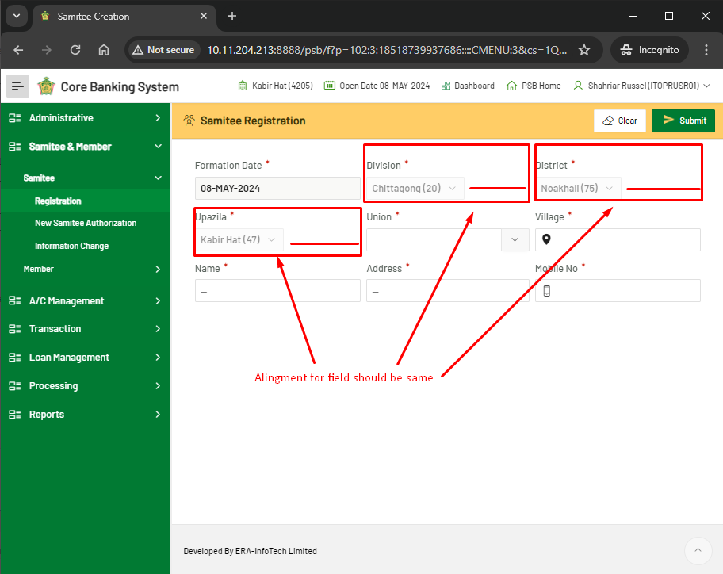

**Member: (Individual – Registration)**

1. “New Member Entry” and “Pending Member” button size is not same.

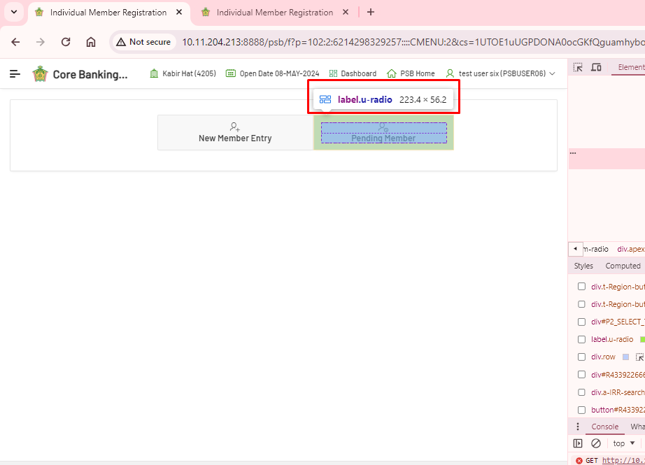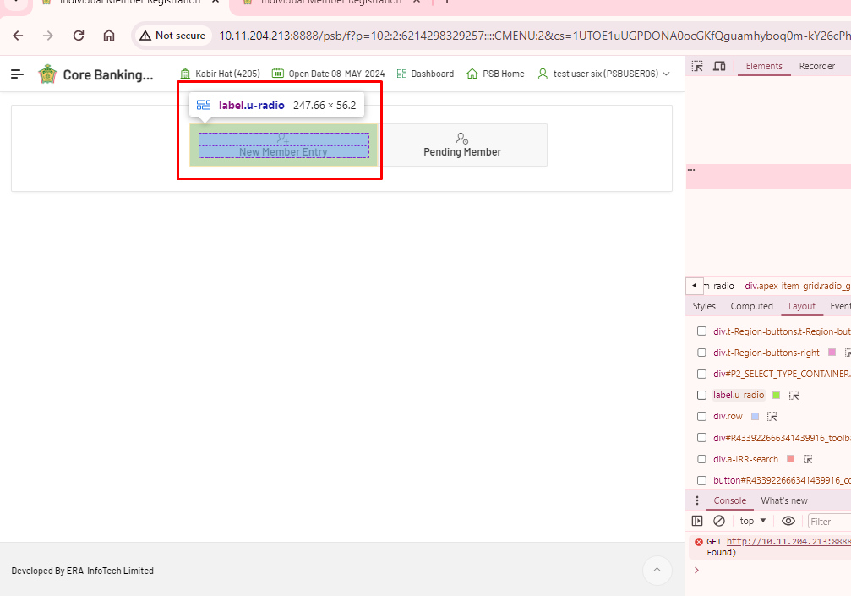

1. Alignment problem in Member registration in Member Registration – Emergency Contact, “Relation” field. It is not page responsive.

